**Rebecca Birkett | Music player Documentation | planning**

# Project requirements

## Overview

“You work for Rebmem Engineering that produces solutions for external clients. They wish to produce their own media player. They have the capability to produce the electronic hardware but need an interface to allow for the sale of the device as a portable music player.”

## Objectives

1. “Design, configure, test and install a Music player that meets business requirements.”
2. “Roll out within the agreed time frame of a maximum of 5 days.”
3. "Build an interface that allows for continuous improvement.”

# Business requirements

## Analysis

From reviewing the project requirements, I have gathered the below assumptions:

1. Rebmem have the capacity to engineer hardware, therefore software is not necessary to distribute via an app store platform such as Apple App Store, Google Play, etc.

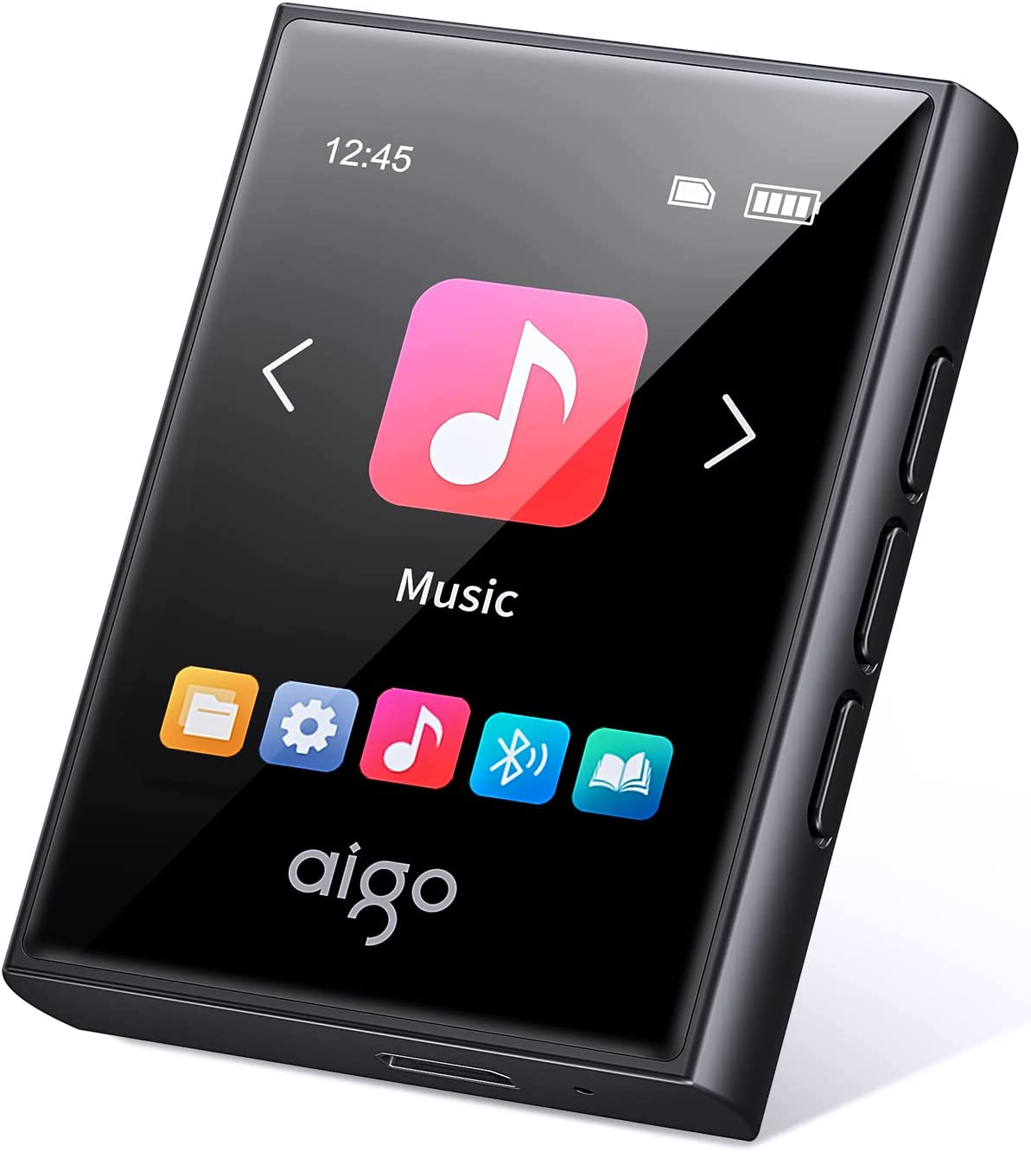

[Example music player](https://www.amazon.co.uk/aigo-Bluetooth-Portable-Lossless-Recorder/dp/B0B67S1DBK/ref=sr_1_5?c=ts&keywords=MP3+&+Digital+Audio+Players&qid=1663152722&s=network-media&sr=1-5&ts_id=573372)

1. The need for an ‘interface’ alludes to the use of buttons, menus and further UI functionality built into the software, therefore the hardware may not accommodate for buttons outside of basic functions (on/off/volume control).
2. Reviewing the current market for music players, and with the above assumptions, I can garner that the hardware may look similar to the example shown [1.1] with touch screen functionality.
3. ‘Music player’ should include the most fundamental playback controls including play, pause, shuffle and loop.
4. ‘Wish to produce their own music player’ could suggest that future development of the product would allow for the playback of other media types, including video files.

**Rebecca Birkett | Music player Documentation | planning**

# Functional requirements

|  |  |
| --- | --- |
| **ID #** | **functional requirement Details** |
| **1.0 Audio Player** | |
| 1.1 | Play an audio file. |
| 1.2 | Control the playback (pause / play) of an audio file. |
| 1.4 | Shuffle a list of audio files and play one at random. |
| 1.5 | Repeat an audio file once or continuously. |
| **2.0 Playlist Management** | |
| 2.1 | Create a playlist. |
| 2.2 | Edit the name of a playlist. |
| 2.3 | Search for a song based on a search term. |
| 2.4 | Sort any search results by song or album title. |
| **3.0 Power Saving Functionality** | |
| 3.1 | Switch to idle mode after 30 seconds of no interaction. |
| 3.2 | Allow music to be played during idle mode. |
|  |  |
|  |  |

**Rebecca Birkett | Music player Documentation | planning**

# non-Functional requirements

|  |  |
| --- | --- |
| **ID #** | **non-functional requirement Details** |
| 1 | Edit and delete playlists. |
| 2 | Allow the user to skip or rewind an audio file. |
| 3 | Carousel home menu to add continuous improvements. |
| 4 | Song focus tray to control current music when in different menus. |
| 5 | Choose from a selection of pre-set royalty free wallpapers. |
| 6 | Built-in help menu with basic user guide. |
| 7 | Swipe to edit and delete. |
| 8 | Show the user remaining device battery life and current time. |
| 9 | ‘Favourite’ songs into a global, default playlist |
|  |  |
|  |  |
|  |  |
|  |  |

I scoped these non-functional requirements in the hopes that they could be added if time permits or in future iterations of the project.

**Rebecca Birkett | Music player Documentation | planning**

# User interface diagramImage

**Rebecca Birkett | Music player Documentation | planning**

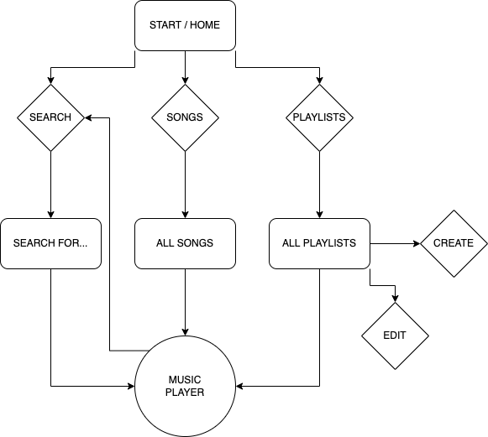

# Flow diagram

**Rebecca Birkett | Music player Documentation | planning**

# Sequence diagrams

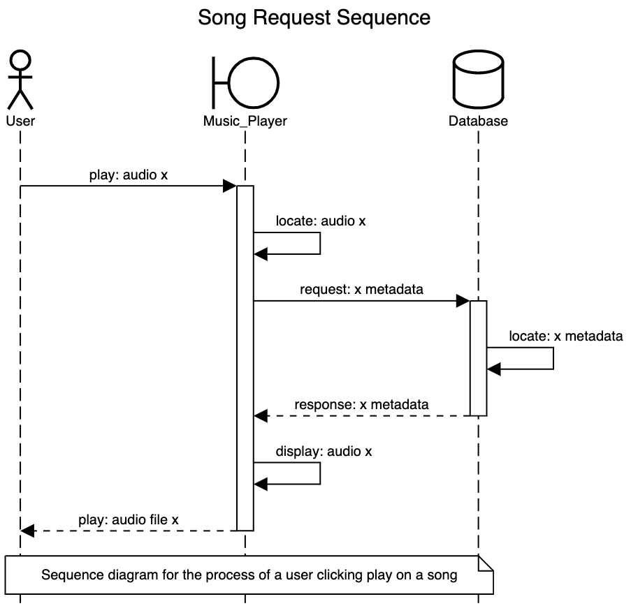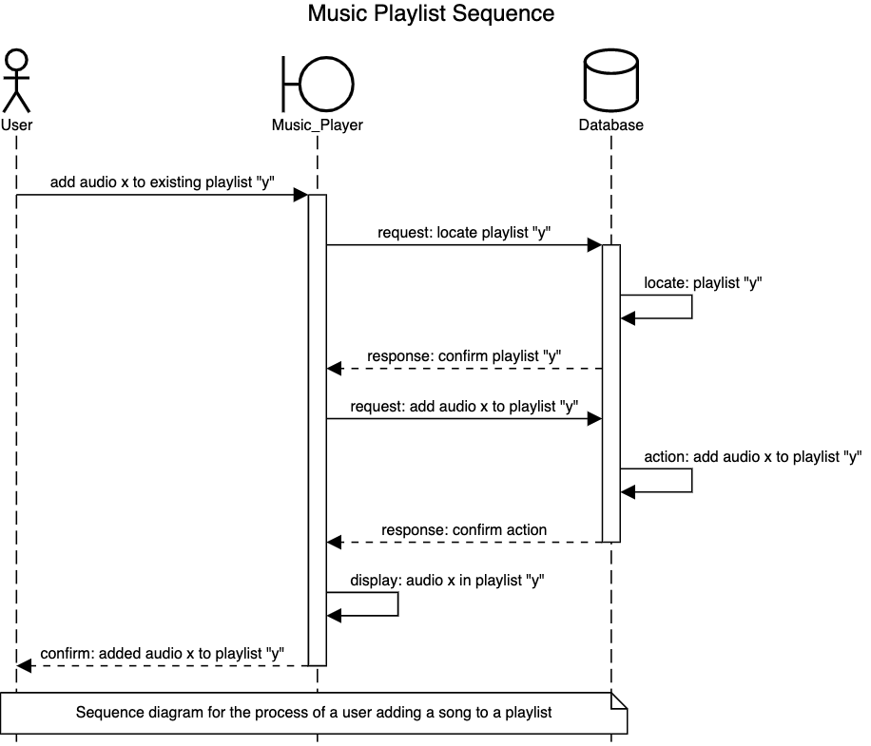

**Rebecca Birkett | Music player Documentation | planning**

# Entity relationship diagramImage

Each song has an ID generated by MongoD, a title (eg. ‘Hyper Beam’), an artist (eg. ‘MDK’), an album (eg. ‘The Singles’), an image (eg. ‘/resources/default.png’) and a filename (eg. ‘/resources/hyperbeam_mdk.mp3’).